A Study on Photophysical Properties of 4- Dimethyl Amino Benzaldehyde Inclusion complex with a-CD

*M. Shirly Treasa and Lizy Roselet

Department of Chemistry, Holy Cross College (Autonomous), Nagercoil – 4 Affiliated to Manonmaniam Sundaranar University, Tirunelveli - 627012
*Corresponding Author - Email: shirlytreasa@holycrossngl.edu.in

ABSTRACT
The present study aims to improve the photophysical property of 4-dimethyl amino benzaldehyde (DMAB) by complexing with α-CD. The photophysical properties of the complex are investigated by UV- Visible, Fluorescence and FTIR spectroscopy. The association constant of the inclusion complex is determined by the Benesi – Hildebrand relation and the inclusion ratio is found to be 1:1. The water solubility of 4-dimethyl amino benzaldehyde is increased by inclusion with α-CD according to the phase solubility diagram. The result obtained from FTIR spectroscopy confirms the inclusion of 4-dimethyl amino benzaldehyde into cyclodextrin cavity.
Keywords: DMAB, α-CD, complexation, photophysical property.

Introduction
Benzaldehyde derivatives are the most interesting carbonyl containing system and they are used chiefly in the synthesis of other organic compounds, ranging from pharmaceuticals to plastic additives. Due to the highly interesting nature of the aldehyde group with the surrounding media and conjugation of the phenyl ring, they are important intermediates for the processing of perfume and flavouring compounds and in the preparation of certain aniline dyes [1]. Recent spectroscopic studies of the benzaldehydes and their derivatives have been motivated because the vibrational spectra are very useful for the understanding of specific biological process and for the analysis of relatively complex systems. The properties such as optical transmission, refractive index, electro-optic effect and dielectric constant of 4-dimethyl amino benzaldehyde (DMAB) have been evaluated.
4-dimethyl amino benzaldehyde (DMAB) is an organic compound containing amine and aldehyde moieties which is used in Ehrlich’s reagent and Kovac’s reagent to test for indoles[2]. It has a role as chromogenic compound. It also is a member of benzaldehydes, a substituted aniline and a tertiary amino compound.
Several vibrational spectroscopic studies on mono-, di-, tri- substituted benzaldehydes have been reported. In this chapter the effect of α-CD on the absorption and fluorescence spectra of 4-dimethyl amino benzaldehyde have been investigated. The possible inclusion complex and comparision of spectral properties of this complex with α-CD are studied. The

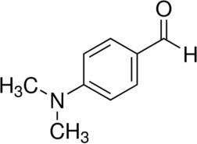
inclusion complex formed is confirmed by UV-Visible spectroscopy, Fluorescence spectroscopy, Phase solubility study and FTIR spectroscopy.

Fig 1. Chemical Structure of 4-dimethyl amino benzaldehyde
This chapter deals with the identification and characterization of 4-dimethyl amino benzaldehyde. The effect of α-CD on the absorption and fluorescence spectra of 4-dimethyl amino benzaldehyde have been investigated in this chapter. Different analytical techniques such as Fourier transform Infrared spectroscopy (FTIR) and phase solubility studies have been used to confirm the inclusion complex formation.

Materials and Methods
4-dimethyl amino benzaldehyde was obtained as gift sample from IPCA laboratories ltd. Mumbai, India. α-CD was purchased from Sigma Aldrich. Both were used as received with no further purification. All other reagents and chemicals were of analytical grade.

Preparation of liquid inclusion complex
The liquid inclusion complex was prepared by adding constant volume of 4-dimethyl amino benzaldehyde drug separately into 10mL volumetric flask containing the absence and presence of increasing concentrations (2-10mM) of α-CD.

UV- Visible Spectral analysis
The UV-Visible spectra were carried out with systronic Double beam spectro photometer-2203. All UV–Visible spectra were taken with reference to the corresponding blank solution.

Fluorescence emission
Fluorescence spectral measurements were carried out with JASCO Spectrofluorometer FP-8200.

Phase solubility studies
Phase solubility studies were performed according to the method reported by Higuchi and Cornors [3] 4-dimethyl amino benzaldehyde in amounts that exceeded its solubility , were taken into vials to which were added 15mL of distilled water (pH 6.8) containing various concentration of α-CD ( 2-10mM). These flasks were sealed and shaken at room temperature

for 5 days to reach equilibrium and the samples were filtered immediately through a 0.45µ nylon disc filter and appropriately diluted. A portion of the sample was analysed by UV spectrophotometer against blank prepared in the same concentration of α-CD in water so as to cancel any absorbance that may be exhibited by the α-CD.

Preparation of solid inclusion complex
Solid dispersion / Co- evaporated dispersion method
The solid inclusion complex of 4-dimethyl amino benzaldehyde with α-CD in 1:1 molar ratio were prepared by dissolving the drug in methanol and α-CD is dissolved in water separately (Jain, 2004). The α-CD solution is added to drug solution and stirred for about 48hours at room temperature to attain equilibrium. The resulting solution was evaporated to dryness [4].

Fourier Transform Infrared Spectroscopy
Infra–Red spectroscopy is used to estimate the interaction between cyclodextrin and the guest molecules in the solid state. FTIR spectra were obtained using JASCO FT 761 photometer at SIC-SFRC. The sample of pure drug 4-dimethyl amino benzaldehyde, α-CD and solid inclusion complexes were previously grounded and thoroughly mixed with KBr. The KBr disks were prepared by compressing the powder blend. The FTIR spectra were executed at a resolution of 1cm⁻¹ (from 4000-400cm⁻¹).

Results and Discussion
Absorption Study
Table 1 and Fig.2 represents the absorption spectra of 4-dimethyl amino benzaldehyde with varying concentration of α-CD. A red shift with an increases in the absorbance is noticed for the absorption spectrum of the guest molecule 4-dimethylamino benzaldehyde (242.5nm to 245.5nm) by increasing the concentration of α-CD.

Table 1. Absorption maxima 4-dimethyl amino benzaldehyde at different concentration of α-CD
α-CD  concentration | λmax(nm) | Absorbance
0 | 242.5 | 0.527
0.002 | 243.5 | 0.588
0.004 | 244.0 | 0.627
0.006 | 244.5 | 0.694
0.008 | 245.0 | 0.784
0.01 | 245.5 | 0.840

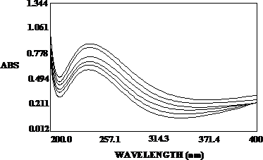

Fig 2. Absorption spectrum of DMAB with α-CD

Fluorescence Study
The inclusion complex formation generally leads to the change of excitation and emission wavelength of the drug[6]. Table 2 and Fig.3 represents the effect of α-CD on the fluorescence spectra of 4-dimethyl amino benzaldehyde. A red shift with an increase in the fluorescence intensity is noticed in the emission spectrum of 4-dimethyl amino benzaldehyde (360 nm to 377nm).These results show that 4-dimethyl amino benzaldehyde is entrapped in α- CD to form inclusion complexes.

Table 2. Fluorescence maxima of 4-dimethyl amino benzaldehyde at different concentration of α-CD
α-CD concentration |  | λflu(nm) | Intensity
0 |  | 360 | 113.397
0.002 |  | 368 | 137.206
0.004 |  | 372 | 149.111
0.006 |  | 374 | 153.398
0.008 |  | 376 | 155.063
0.01 |  | 377 | 161.016
225

200

175

150

125

100

75

50

25

200
INTENSITY
300
400
WAVELENGTH (nm)
500
600

Fig 3. Emission spectra of DMAB with α-CD

The association constant (K) for the formation of inclusion complexes is determined from the changes in the absorption and fluorescence intensity of the guest molecule with increasing the concentration of α-CD using Benesi-Hildebrand equation[7]. The equation for 1:1 complexes are
Absorption

Fluorescence
1
A − A0
= 1 +
A − A0
1
K ( A − A₀ )[α − CD]

1
I − I 0
= 1
I − I 0
+ 1
K (I − I₀ )[α − CD]

In the above equation A0/ I0 is the intensity of absorbance / fluorescence of 4-dimethyl amino benzaldehyde without α-CD, A/I is the absorbance/ fluorescence intensity with a particular concentration of α-CD. A good linear correlation is obtained from the graph drawn between concentration of α-CD and intensity of absorbance/emission. The association constant for absorption and emission is calculated from the slope of the graph.
For absorption

K = 1
Slope( A − A₀ )
= 386 for 4-dimethyl amino benzaldehyde : α-CD inclusion complexes.

For emission

K = 1
Slope(I − I₀ )
= 404 for 4-dimethyl amino benzaldehyde : α-CD inclusion complexes.

This analysis reveals that the drug molecule 4-dimethyl amino benzaldehyde form 1:1 inclusion complexes with α-CD. The higher value of association constant for absorption and emission confirms that 4-dimethyl amino benzaldehyde include firmLy in the cavity of α-CD.

Phase solubility study
Fig.4 represents the phase solubility diagram of α-CD: 4-dimethyl amino benzaldehyde liquid inclusion complex. From the diagram it is observed that the drug solubility increases linearly by increasing α-CD concentration. The diagrams are considered as AL type according to the model proposed by Higuchi and Carnors. The apparent stability constant (Ks) is found to be 307M⁻¹ for α-CD:4-dimethyl amino benzaldehyde complex. The higher stability constant value confirms the higher solubilizing capacity of DMAB.

6.2

6.0

5.8

5.6

5.4
conc. of DMAB X 10 -3

5.2

5.0

4.8

4.6

4.4

4.2

4.0

3.8

3.6

0.00

0.002 0.004 0.006 0.008 0.01
conc. of alpha cyclodextrin

Fig 4. Phase solubility diagram of α-CD : DMAB
3.4 Fourier Transform Infrared (FTIR) Spectroscopic study
The FTIR spectrum of pure α-CD (Fig.5) shows characteristic peak at 3382.91cm⁻¹ (O- H stretching vibration), 2925.81cm⁻¹ (C-H), 1641.31 cm⁻¹(H-O-H bending), 1155.28 cm⁻¹(C- O) and 1029.92cm⁻¹ (C-O-C).
The FTIR spectrum of 4-dimethyl amino benzaldehyde and solid inclusion complex are shown in the Fig. 6 and 7. The N-H stretching frequency appeared at 3317.56cm⁻¹ in the original sample is appeared at 3379.29cm⁻¹ in the solid inclusion complex. The C-H methyl stretching frequency appeared at 2900.94cm⁻¹ and 2816.07cm⁻¹ is shifted to 2924.09cm⁻¹and 2823.79cm⁻¹ in the inclusion complex. The C=O stretching modes of aldehyde group observed at 1666.50cm⁻¹ in the original sample is shifted to 1658.78 cm⁻¹ in the inclusion complex whereas the C-H peak at 2731.20cm⁻¹ in the original sample is appeared at same frequency in the inclusion complex. The intensity in the inclusion complex was significantly different from original sample. This indicates that the guest molecule DMAB are included in the cavity of α- CD.
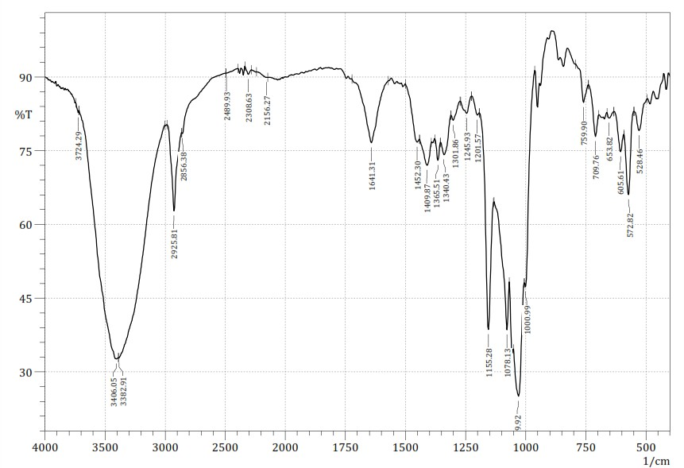

Fig 5. FTIR Spectrum of α-CD

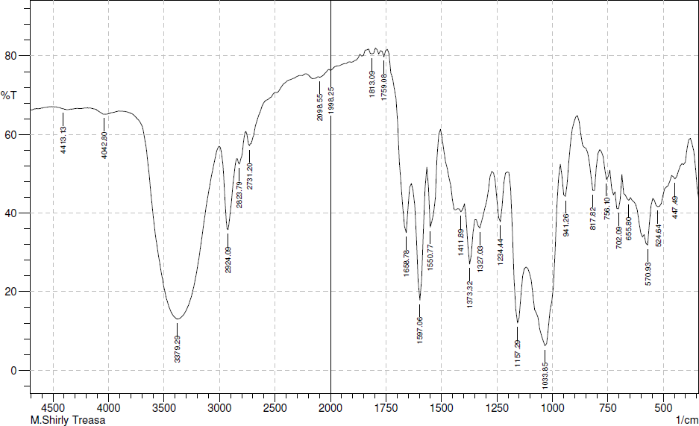
Fig 6. FTIR spectrum of DMAB

Fig 7. FTIR spectrum of α-CD:DMAB inclusion complex
- Conclusion
From these observations it is concluded that the organic fluorophore 4-dimethyl amino benzaldehyde form 1:1 inclusion complex with α-CD. The phase solubility study proves the solubility of 4-dimethyl amino benzaldehyde enhanced by the addition of α-CD. The association constant and solubility constant of 4-dimethyl amino benzaldehyde inclusion complexes are higher. These results show that the organic fluorophore 4-dimethyl amino benzaldehyde is fully included in α-CD cavity.

References
- Tayade P.T., Vavia P.R. Inclusion complexes of Ketoprofen with β- cyclodextrins: Oral pharmacokinetics of Ketoprofen in human. Indian. J. Pharm. Sci. 2006; 68: 164 - 170.
- Jadhav G.S., Vavia P.R. Physicochemical in silico and in vivo evaluation of a Danazol - β- cyclodextrin complex. Int. J. Pharm. 2008; 352: 5 - 16.

- Higuchi T., Connors A.K. Phase-solubility techniques, Advances in Analytical Chemistry and Instrumentation. 1965; 4: 117 - 212.
- Jain N.K. Progress in controlled and Novel Drug Delivery System. Cyclodextrin Based Drug Delivery System. 2004; 1: 384 - 400.
- Wenz G., Hofler T., Wehrle S., Schneider M. Inclusion of pharamaceutical drugs in cyclodextrins as measured by titration microcolorimetry. Polymer Preprints.1988; 39: 202
- 203.
- Aithal K.S., Udupa N., Sreenivasan K.K. Physicochemical properties of drug-cyclodextrin complexes. Indian Drugs. 1995; 32: 293 - 305.
- Benesi H.A., Hildebrand J.H., J. Am Chem. Soc. 1949; 4: 132 - 138.

